Austin Smothers

CISP 430

Assignment 6

*Turned in late due to my right lung collapsing
/*BinTreeIMP.cpp

Author:
Austin Smothers

Original October 2017

Description:
Creates a binary tree given a pre-determined set of data.
Stores the tree's root in a pointer before moving on to the next tree.
Performs searches for data values, as well as:
preorder, postorder, and inorder outputs
of the data stored within the tree

*/

#include<iostream>
#include<array> //included for sizeof() function
using namespace std;

//structure definition
struct node {
int data; //the value stored within a node
node *left; //left child
node *right; //right child
};

//Function Prototypes/Declarations
void insert(int data); //creates a new node and inserts it in the
correct location in the tree
void print_preorder(node *root); //print the data in a tree using a preorder
traversal
void print_postorder(node *root); //prints the data in a tree using a postorder
traversal
void print_inorder(node *root); //prints the data in a tree using an inorder
traversal
void oput(int n); //handles output for the search function
int search(int data); //searches the tree for data. returns 0 if data
not found, otherwise, returns the number of
nodes visited

//Global Data
int AMEMES[] = { 1, 5, 4, 6, 7, 2, 3 };
int BMEMES[] = {
150, 125, 175, 166, 163, 123, 108, 116, 117, 184,
165, 137, 141, 111, 138, 122, 109, 194, 143, 183,
178, 173, 139, 126, 170, 190, 140, 188, 120, 195,
113, 104, 193, 181, 185, 198, 103, 182, 136, 115,
191, 144, 145, 155, 153, 151, 112, 129, 199, 135,
146, 157, 176, 159, 196, 121, 105, 131, 154, 107,
110, 158, 187, 134, 132, 179, 133, 102, 172, 106,
177, 171, 156, 168, 161, 149, 124, 189, 167, 174,
147, 148, 197, 160, 130, 164, 152, 142, 162, 118,
186, 169, 127, 114, 192, 180, 101, 119, 128, 100}; //array that stores data
const int ASIZE = sizeof(AMEMES) / sizeof(int); //# elements in sequence A
const int BSIZE = sizeof(BMEMES) / sizeof(int); //# elements in sequence B
node *root = NULL; //the root node pointer
//THE MAIN FUNCTION

void main() {

int i = 0;

//insert function calls
cout << "Sequence A: " << endl;
for (i = 0; i < ASIZE; i++) {
insert(AMEMES[i]);
cout << AMEMES[i] << " ";
}
cout << endl << endl; //asthetic line break
node *a = root; //a node to store the root of the A tree
root = NULL; //reset the root node since a has the old root

cout << "Sequence B: " << endl;
for (i = 0; i < BSIZE; i++) {
insert(BMEMES[i]);
cout << BMEMES[i] << " ";
if ((i+1) % 10 == 0)
cout << endl;
}
cout << endl; //asthetic line break
node *b = root; //a node to store the root of the B tree

//oput & nested search function calls
i = 196;
oput(i);

i = 137;
oput(i);

i = 102;
oput(i);

i = 190;
oput(i);

cout << endl; //asthetic line break

//print_preorder of the a tree
cout << "Preorder: ";
print_preorder(a);
cout << endl;

//print_postorder of the a tree
cout << "Postorder: ";
print_postorder(a);
cout << endl;

//print_inorder of the a tree
cout << "Inorder: ";
print_inorder(a);
cout << endl;

}//runs in O(N) time, where N is equal to the SIZE of the sequence we are building a tree for
//PROTOTYPE DEFINITIONS

/*Inserts a value into a new node and links it in the existing Binary Tree
based on the value passed*/
void insert(int d) {

node *r = new node; //the node to be inserted
node *t = root; //a dummy node pointer used to traverse the tree

r->data = d; //set r's value
r->left = NULL;
r->right = NULL; //r will be a leaf

//if root does not exist, create it and set it equal to r
if (!root) {
root = r;
//cout << root->data << " "; //debugging
return;
}

//a while loop to walk down the tree (no messy recursion needed)
while (t) {

//walk left if d is less than current node
if (r->data < t->data && t->left) {
t = t->left;
//cout << "Going left.\n"; //debugging
}
//d must be more than current node, walk right
else if (r->data >= t->data && t->right) {
t = t->right;
//cout << "Going right.\n"; //debugging
}
//t->left & t->right must both be null, or are bad options.
else
break;
}
//loop while not at an insertion point

//we must be at an insertion point

//insert left if d is less than current node
if (r->data < t->data) {
t->left = r;
t = t->left;
//cout << "Inserting " << t->data << " left.\n"; //debugging
}
//d must be more than current node, insert right
else {
t->right = r;
t = t->right;
//cout << "Inserting " << t->data << " right.\n"; //debugging
}
}/*runs in O(N) time, where N is the height of the tree when the function is called. the insert function runs on a while loop which iterates once per unit height of the tree*/
/*recursive function which traverses a tree
using a preorder traversal and prints out the tree*/
void print_preorder(node *root) {
if (root != NULL) {
cout << root->data << " ";
print_preorder(root->left);
print_preorder(root->right);
}
}
/*runs in 2N+1 time, where N is the number of nodes in the tree,
as for each node, there is one child and one "empty" node, excepting
the leaf, which will have two "empty" nodes*/

/*recursive function which traverses a tree
using a postorder traversal and prints out the tree*/
void print_postorder(node *root) {
if (root != NULL) {
print_postorder(root->left);
cout << root->data << " ";
print_postorder(root->right);
}
}
/*runs in 2N+1 time, where N is the number of nodes in the tree,
as for each node, there is one child and one "empty" node, excepting
the leaf, which will have two "empty" nodes*/

/*recursive function which traverses a tree
using an inorder traversal and prints out the tree*/
void print_inorder(node *root) {
if (root != NULL) {
print_inorder(root->left);
print_inorder(root->right);
cout << root->data << " ";
}
}
/*runs in 2N+1 time, where N is the number of nodes in the tree,
as for each node, there is one child and one "empty" node, excepting
the leaf, which will have two "empty" nodes*/

/*function which handles output for the search function
because I'm not copy pasting output code for four searches*/
void oput(int n) {
int i = search(n);
if (i)
cout << "Number of nodes visited to find " << n << ": " << i << endl;
else
cout << "Could not find: " << n << endl;
}
//runs in O(1) time, excecuting once per call, no matter what n is

/*function to search through the most recently assembled tree
for a number (data)*/
int search(int data) {
node *t = NULL; //a dummy pointer to traverse the tree
int i = 0; //counter used to track # of nodes visited

if (root) //if root is null, t stays null, no trees
t = root; //if root exists, start t at root

//while the t node is not NULL, keep searching
while (t) {
//increment i to count how many nodes we have visited
i++;

//if we found the # we're looking for return i
if (data == t->data)
return i;

//if the # we're looking for is less than the current t
else if (data < t->data && t->left)
t = t->left; //go left

//value we are looking for must be greater than current t
else if (data > t->data && t->right)
t = t->right; //go right

//seems we are at a leaf and can't find the data
else
break; //break the loop
}
//must not have found the data, return 0
return 0;
}
/*runs in Olog(N)base2, where N is equal to the number of nodes in the tree being searched.
This is because the search function should only ever have to search half the tree
to find a piece of data*/
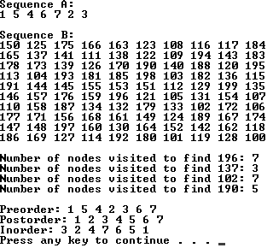
Sequence A Tree: 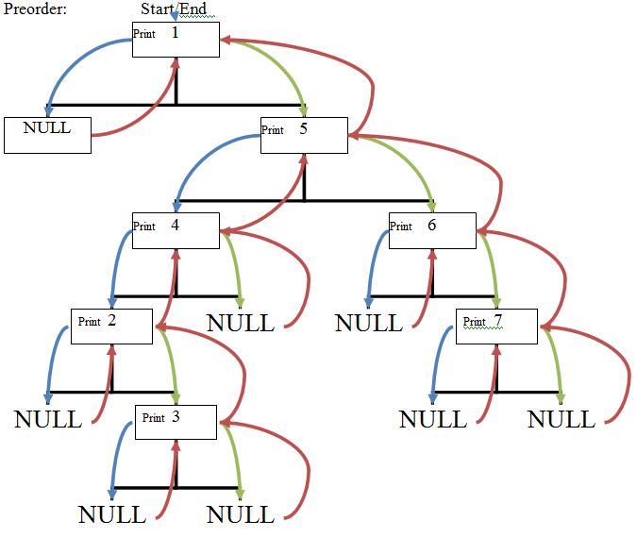
1
NULL
5
4
6
NULL
7
2
NULL
NULL
NULL
NULL
3
NULL
NULL
